|  |  |
| --- | --- |
| **List of Figures** |  |
|  |  |
| **Abstract** |  |
|  |  |
| **CHAPTER 1: INTRODUCTION** |  |
| 1.1 Overview |  |
| 1.2 Literature Survey |  |
|  |  |
| **CHAPTER 2: PROBLEM IDENTIFICATION &SCOPE** |  |
| 2.1 Problem Domain |  |
| 2.2 Solution Domain |  |
| 2.3 Need & Scope |  |
|  |  |
| **CHAPTER 3: SOFTWARE ENGINEERING APPROACH** |  |
| 3.1 Software model used |  |
| 3.1.1 Description |  |
| 3.1.2 Reason for use |  |
| 3.2Platform Specification |  |
| 3.2.1 Hardware Specification |  |
| 3.2.2 Software Specifications |  |
|  |  |
| **CHAPTER 4: DESIGNS** |  |
| 4.1 Use Case Diagram |  |
| 4.2 Sequence Diagram |  |
| 4.3 Class Diagram |  |
|  |  |
|  |  |
| **CHAPTER 5: IMPLEMENTATION PHASE** |  |
| 5.1 Language Used & its Characteristics |  |
| 5.2 Modules Detail |  |
| 5.3 GUI (Snapshots) with description of each GUI |  |

|  |  |
| --- | --- |
|  |  |
| **CHAPTER 6: TESTING METHOD** |  |
| 6.1Testing Method |  |
| 6.2 Test Cases |  |
|  |  |
| **CHAPTER 7: CONCLUSIONS** |  |
|  |  |
| **CHAPTER 8: LIMITATIONS & FUTURE ENHANCEMENTS** |  |
|  |  |
| **REFERENCES** |  |
|  |  |

v

## LIST OF FIGURES

|  |  |  |
| --- | --- | --- |
| **Figure No** | **Title** | **Page No.** |
| Figure 4.1.1 | Use case Diagram | 28 |
| Figure 4.2.1 | Sequence Diagram | 29 |
| Figure 4.3.1 | Class Diagram | 31 |
| Figure 5.3.1 | Snapshot of Home automation system | 35 |

## ABSTRACT

Home automation systems have gained significant popularity due to their ability to enhance convenience, security, and energy efficiency. This project focuses on developing a smart home automation system using ESP8266 NodeMCU, integrating multiple sensors and actuators to monitor and control various home appliances. The system includes an MQ2 gas sensor for detecting harmful gases, a flame sensor for fire detection, a PIR motion sensor for intruder detection, and a buzzer for alert notifications. An OLED display provides real-time status updates, while a 2-channel relay module allows remote control of connected electrical devices. The system is connected to Wi-Fi, enabling users to monitor and control their home environment through a web interface. Additionally, it features email notifications to alert users in case of emergencies, enhancing home security and responsiveness.

This automation system is designed to be cost-effective and scalable, making it suitable for both residential and commercial applications. The integration of IoT technology ensures remote accessibility, allowing users to interact with the system from anywhere via an internet connection. The web-based interface provides an intuitive platform for monitoring sensor readings and managing connected appliances. The system’s real-time alert mechanism enhances safety by promptly notifying users of potential hazards. By utilizing ESP8266 microcontrollers, the project demonstrates an efficient and reliable approach to smart home automation, contributing to the growing field of IoT-based home security and control systems.

Furthermore, this home automation system is designed with scalability in mind, allowing additional sensors and modules to be integrated as needed. The use of Wi-Fi connectivity ensures seamless communication between the microcontrollers and the web interface, enabling real-time monitoring and control from any internet-enabled device. The system not only enhances security by detecting gas leaks, fire, and unauthorized movement but also improves energy efficiency by enabling remote control of electrical appliances. With a user-friendly web interface and automated alert mechanisms, this project demonstrates an innovative approach to modernizing home management, making everyday living safer, smarter, and more convenient.

**CHAPTER -1**

## INTRODUCTION

**1.1 OVERVIEW:**

A home automation system is a smart technology that integrates various electronic devices, sensors, and actuators to provide remote and automated control over household appliances and security features. These systems leverage IoT (Internet of Things) technology to create an interconnected environment where users can monitor and control lighting, temperature, security, and other home functions through a web interface or mobile application. The use of microcontrollers ESP8266, along with sensors such as motion detectors, gas sensors, and flame sensors, allows for real-time data collection and response to environmental changes. This automation enhances convenience, safety, and energy efficiency, reducing human intervention in routine household tasks.

One of the key advantages of a home automation system is its ability to improve security. Motion sensors, cameras, and alarm systems can detect unauthorized entry and send instant alerts to homeowners via email or push notifications. Additionally, sensors like MQ2 for gas detection and flame sensors for fire detection help prevent accidents by triggering immediate responses, such as activating buzzers or shutting down appliances. These systems not only ensure safety but also provide peace of mind to users by enabling remote monitoring from any location with an internet connection.

Energy efficiency is another crucial benefit of home automation. Smart lighting and temperature control systems allow users to optimize energy consumption by automatically adjusting settings based on occupancy or time of day. For instance, lights can be programmed to turn off when no movement is detected, and thermostats can regulate indoor temperatures based on weather conditions or user preferences. By reducing unnecessary power usage, these systems contribute to cost savings and environmental sustainability.

The scalability and flexibility of home automation systems make them suitable for various applications, ranging from small apartments to large commercial buildings. Additional sensors, actuators, and modules can be integrated to expand functionality as needed. The continuous advancement of IoT and AI (Artificial Intelligence) technologies is further enhancing automation capabilities, making homes smarter and more efficient. As the demand for smart home solutions grows, home automation is becoming an essential aspect of modern living, offering a seamless and intelligent way to manage household operations.

Furthermore, home automation plays a significant role in assisting individuals with disabilities or elderly people. Smart voice-controlled assistants, automated lighting, and remote-controlled security systems allow individuals with mobility challenges to interact with their surroundings effortlessly. This improves their quality of life by increasing independence and safety. Features such as automated door locks, emergency alerts, and fall detection sensors make homes safer for elderly individuals, reducing the risk of accidents.

In addition to security and energy efficiency, home automation enhances overall comfort and convenience. Smart entertainment systems, automated window blinds, and scheduled appliance control allow users to personalize their living environment. For instance, users can program coffee makers to start brewing in the morning or set air conditioners to maintain a preferred temperature before they arrive home. These automated routines help create a more comfortable and customized living experience.

As technology continues to advance, home automation is expected to become even more sophisticated with the integration of AI and machine learning. Future systems will be capable of analyzing user behaviour and preferences to make intelligent predictions and adjustments automatically. The integration of smart home automation with voice assistants like Amazon Alexa and Google Assistant further simplifies user interaction. With the rise of smart cities and interconnected systems, home automation will continue to play a crucial role in shaping modern lifestyles, offering enhanced security, efficiency, and convenience for homeowners worldwide.

**1.2 LITERATURE SURVEY:**

1. Introduction Home automation systems have gained significant traction in recent years due to advancements in embedded systems, IoT, and wireless communication technologies. These systems enhance convenience, security, and energy efficiency by enabling remote control of household appliances and real-time monitoring of environmental conditions. This literature survey explores various methodologies and technologies used in home automation.
2. Existing Home Automation Technologies Several approaches have been employed to develop home automation systems, including:
   1. Wired Automation Systems Traditional home automation relied on wired networks to control and monitor appliances. Protocols such as X10, BACnet, and KNX were widely used. However, wired systems are costly and difficult to install and modify.
   2. Wireless Home Automation Systems With the advent of wireless technologies, home automation has shifted towards flexible and cost-effective solutions. The most commonly used wireless technologies include:
      * Wi-Fi-Based Systems: These systems use Wi-Fi connectivity to allow users to control appliances through web or mobile applications. ESP8266 and ESP32 microcontrollers have facilitated the development of affordable and efficient Wi-Fi-based home automation.
      * Bluetooth-Based Systems: Bluetooth-based automation allows short-range control of devices via smartphones or tablets. Although power-efficient, these systems have limited range compared to Wi-Fi.
      * Zigbee and Z-Wave Protocols: These are low-power, mesh-networking protocols used in smart homes for device communication.
      * RFID and GSM-Based Systems: These systems enable remote monitoring and control using mobile networks and SMS.
3. Sensor Integration in Home Automation Modern home automation systems integrate various sensors for enhanced functionality:
   * + MQ2 Sensor: Detects smoke and gas leakage for fire safety.
     + Flame Sensor: Detects fire or high heat levels.
     + PIR Sensor: Detects motion and unauthorized entry.
     + Temperature and Humidity Sensors: Provide environmental monitoring for HVAC systems.
     + Buzzer and OLED Display: Provide alerts and notifications regarding sensor readings.
4. Web-Based and Cloud-Connected Automation With the rise of cloud computing, home automation systems are now integrated with cloud platforms for remote monitoring and control. IoT platforms such as Firebase, AWS IoT, and Blynk enable users to access and control their home appliances via the internet. The implementation of real-time alert mechanisms through email and push notifications enhances system usability.
5. Security and Privacy Concerns While home automation offers convenience, it also introduces security risks, such as unauthorized access, data breaches, and hacking threats. Implementing robust encryption, secure authentication mechanisms, and firewall protections can mitigate these risks.
6. Conclusion Home automation systems continue to evolve with advancements in IoT, AI, and embedded technologies. Wireless communication, sensor integration, and cloud connectivity have made automation systems more efficient and accessible. Future research aims at enhancing security, reducing power consumption, and improving interoperability between different automation standards.

**CHAPTER -2**

## PROBLEM IDENTIFICATION & SCOPE

**2.1 PROBLEM DOMAIN:**

Problem Domain in Home Automation

1. Introduction The home automation sector has witnessed significant advancements with the integration of IoT, wireless communication, and smart devices. However, several challenges still persist, affecting the efficiency, security, and affordability of these systems. This section outlines the key problem domains associated with home automation.
2. Key Problem Areas
   1. Energy Efficiency and Management Managing household energy consumption effectively remains a major challenge. Many appliances operate inefficiently, leading to excessive electricity usage and increased costs. The absence of real-time monitoring and intelligent scheduling further exacerbates energy wastage, highlighting the need for automated energy management systems.
   2. Security and Surveillance Home automation systems are vulnerable to security threats, including unauthorized access and cyber-attacks. Many existing solutions lack comprehensive integration between surveillance cameras, motion sensors, and alert mechanisms. Enhancing security through automated intrusion detection and real-time alerts is essential to ensure user safety.
   3. Remote Monitoring and Control Users often face difficulties in remotely managing and monitoring their home appliances. Limited access to real-time device status and inefficient control mechanisms pose significant usability issues. A user-friendly web or mobile interface is crucial for seamless remote operation of home automation systems.
   4. Integration of Multiple Devices and Protocols A major challenge in smart home automation is the interoperability between devices using different communication protocols. The lack of standardization results in difficulty synchronizing sensors, actuators, and control systems. A unified platform is necessary to facilitate seamless integration and automation.
   5. Safety and Hazard Detection Smart homes require robust hazard detection mechanisms to prevent fire outbreaks, gas leaks, and environmental hazards. Traditional alarm systems often fail to provide timely alerts, making it essential to integrate sensors such as MQ2 for gas detection, flame sensors for fire alerts, and PIR sensors for motion detection. Automated emergency response systems can significantly enhance home safety.
   6. User Privacy and Data Security The increasing reliance on IoT devices raises concerns about data privacy and security. Unsecured smart home networks are vulnerable to hacking, leading to unauthorized access to personal information. Implementing strong encryption, authentication protocols, and secure cloud storage is necessary to safeguard user data.
   7. Connectivity and Reliability Issues Smart home systems often depend on stable internet connectivity, and any disruption can lead to functionality issues. Additionally, reliance on cloud-based services can result in downtime. Ensuring local failover mechanisms and enhancing network reliability can improve the robustness of home automation solutions.
   8. Cost and Affordability The high initial cost of smart home automation solutions is a barrier to widespread adoption. Expensive maintenance and the need for frequent upgrades further add to the financial burden. Developing cost-effective automation systems with optimized performance and minimal maintenance is crucial for mass adoption.
3. Conclusion Addressing these challenges is essential for the widespread adoption of home automation technologies. Future advancements should focus on enhancing energy efficiency, security, device interoperability, and cost-effectiveness. By tackling these issues, smart home systems can become more accessible, reliable, and beneficial for users worldwide.

**2.2 SOLUTION DOMAIN:**

Solution Domain for Home Automation System

1. Introduction The challenges in home automation require innovative and efficient solutions to enhance energy efficiency, security, reliability, and affordability. This section explores the key solutions that address the problem domains identified in home automation.
2. Key Solutions
   1. Energy Efficiency and Management To reduce energy wastage, smart home automation systems can integrate energy-efficient solutions such as:

Smart Power Monitoring: Real-time tracking of power consumption using IoT-based energy meters.

* + - Automated Appliance Control: AI-driven automation that optimizes power usage based on user behaviour.
    - Scheduled Device Operation: Predefined schedules for lights, air conditioning, and appliances to minimize unnecessary energy consumption.
  1. Security and Surveillance Enhancing security is crucial for smart homes. Effective solutions include:
     + IoT-Based Surveillance: Smart cameras, PIR motion sensors, and remote monitoring through a mobile or web application.
     + Automated Intrusion Detection: AI and ML-based anomaly detection for real-time alerts.
     + Encrypted Communication: End-to-end encryption and multi-factor authentication to prevent unauthorized access.
  2. Remote Monitoring and Control For seamless user experience and accessibility, home automation systems should include:
     + Cloud-Based Integration: IoT-enabled smart hubs for real-time control of home appliances via smartphones and web interfaces.
     + Voice and Gesture Control: Integration with virtual assistants like Alexa and Google Assistant for hands-free operation.
     + Real-Time Notifications: Instant alerts and push notifications for system updates and security breaches.
  3. Integration of Multiple Devices and Protocols A standardized communication framework enhances interoperability across different smart devices. Solutions include:
     + IoT Protocols and Middleware: Adoption of MQTT, Zigbee, and Z-Wave for seamless device communication.
     + Centralized Smart Home Hub: A unified controller that bridges different automation protocols.
     + Cloud and Edge Computing: Hybrid solutions for data processing and device synchronization.
  4. Safety and Hazard Detection To enhance home safety, home automation systems should incorporate: • Gas and Smoke Detection: Integration of MQ2 and flame sensors for fire and gas leak alerts.
     + Automated Emergency Responses: Triggering alarms and shutting down appliances during hazardous conditions.
     + Remote Emergency Alerts: Sending notifications via email and SMS for immediate action.
  5. User Privacy and Data Security Protecting user data and ensuring privacy is essential for trust and adoption. Effective solutions include:
     + Secure Authentication: Two-factor authentication and biometric verification for smart home access.
     + Data Encryption: AES and SSL/TLS encryption for secure data transmission.
     + Decentralized Storage: Blockchain-based data management for enhanced security and privacy.
  6. Connectivity and Reliability To overcome network dependency, home automation systems should ensure:
     + Hybrid Connectivity: Combination of Wi-Fi, Bluetooth, and cellular networks for uninterrupted access.
     + Local Processing Capabilities: Edge computing to allow offline functionality.
     + Backup Power Solutions: Integration of UPS and solar power to ensure continuous operation.
  7. Cost and Affordability To make smart home solutions widely accessible, cost-effective approaches include:
     + Open-Source Frameworks: Use of Arduino, ESP32, and Node MCU for low-cost automation solutions.
     + Modular System Design: Scalable systems that allow users to upgrade components gradually.
     + Energy-Efficient Components: Low-power microcontrollers and optimized circuits for cost reduction.

1. Conclusion The implementation of these solutions can significantly enhance the efficiency, security, and usability of home automation systems. By leveraging IoT, AI, and cloud technologies, smart homes can become more intelligent, secure, and cost-effective, paving the way for widespread adoption and future advancements.

**2.3 NEED & SCOPE:**

* + 1. Introduction With the increasing demand for convenience, security, and energy efficiency, home automation has emerged as a crucial technology in modern households. The integration of IoT, AI, and smart devices enables users to control and monitor their homes remotely, improving overall quality of life. This section explores the need and scope of home automation systems in today's world.
    2. Need for Home Automation System Home automation systems address various challenges faced by homeowners, providing numerous benefits:
    - Enhanced Security: Automated surveillance, smart locks, and motion sensors help prevent unauthorized access and intrusions.
    - Energy Efficiency: Smart energy management reduces electricity consumption through automated control of lights, HVAC systems, and appliances.
    - Convenience and Comfort: Remote control and automation of household devices improve ease of use and comfort.
    - Safety Measures: Fire and gas leak detection systems ensure early warning and quick response to hazards.
    - Remote Accessibility: Users can monitor and control their homes from anywhere using mobile apps and web interfaces.
    - Integration with Smart Assistants: Voice-controlled operation via Alexa, Google Assistant, and Siri enhances usability.
    - Cost Savings: Energy-efficient automation lowers utility bills, making home management more economical in the long run.

1. Scope of Home Automation System The implementation of home automation systems is expanding across various domains, providing broad scope for future developments:
   * Smart Energy Management: IoT-enabled power monitoring and optimization help reduce carbon footprints and electricity costs.
   * Security and Surveillance: Advanced AI-driven monitoring systems provide real-time security alerts and remote surveillance.
   * Healthcare and Assisted Living: Smart sensors assist elderly and disabled individuals with health monitoring and emergency response.
   * AI and Machine Learning Integration: Predictive analytics enable personalized automation and efficiency improvements.
   * Scalability and Customization: Modular automation systems allow users to upgrade and customize smart home solutions according to their needs.
   * Industrial and Commercial Applications: Home automation principles are expanding into smart offices, hotels, and industries for improved efficiency and control.
2. Conclusion The need for home automation systems is driven by the demand for enhanced security, convenience, and energy efficiency. With advancements in IoT, AI, and cloud technologies, the scope of home automation is continuously expanding, making smart living more accessible and intelligent. Future innovations will further enhance automation, making homes safer, more efficient, and highly adaptable to user preferences.

**CHAPTER- 3**

## SOFTWARE ENGINEERING APPROACH

**3.1 SOFTWARE MODEL USED:**

**3.1.1 DESCRIPTION:**

The software model for the home automation system follows a layered approach, ensuring modularity, scalability, and ease of integration. It consists of the following key components:

**1. Sensor Layer**

* Collects real-time data from various sensors (MQ2, Flame, PIR).
* Processes raw sensor values and triggers necessary actions.
  1. **Control Layer**
* Runs on the ESP8266 NodeMCU and ESP32-WROOM-32.
* Implements sensor data processing, decision-making logic, and device control.
* Controls the 2-channel relay module and buzzer based on sensor inputs.
  1. **Communication Layer**
* Enables Wi-Fi connectivity for remote monitoring and control.
* Uses MQTT or HTTP protocols for data exchange.
* Sends alert notifications via email in case of security threats.
  1. **Web Interface Layer**
* A user-friendly web dashboard allows remote monitoring and control of appliances.
* Displays real-time sensor data and device statuses.
* Provides control options for activating/deactivating the buzzer and relays.
  1. **Cloud Integration Layer (Optional)**
* Can be integrated with cloud services for data logging and analytics.
* Supports remote access via web servers.

This software model ensures real-time automation, remote accessibility, and security, making the home automation system efficient and intelligent.

**3.1.2 Reason For Use:**

**Reasons for Using a Software Model in a Home Automation System**

A software model is essential in a home automation system for the following reasons:

1. **Modularity and Scalability** 
   * + - The system is divided into different layers (sensor, control, communication, web interface, and cloud), making it easier to modify and expand.
       - Additional sensors or smart devices can be integrated without redesigning the entire system.
2. **Efficient Data Processing** 
   * + - The software model ensures real-time processing of sensor data (MQ2, flame, PIR) for immediate response.
       - Reduces unnecessary triggers by implementing threshold-based decision-making logic.
3. **Remote Monitoring and Control** 
   * + - The communication layer allows users to monitor and control home devices from anywhere using WiFi connectivity.
       - The web interface provides an easy way to control relays and receive alerts.
4. **Security and Safety** 
   * + - The model enables real-time alerts via email notifications in case of fire, gas leaks, or unauthorized motion detection.
       - Ensures immediate activation of the buzzer and relay for emergency responses.
5. **Improved User Experience** 
   * + - A well-structured software model ensures a smooth and user-friendly interaction through a web-based dashboard.
       - Provides a clear interface to view real-time data and manually control appliances.
6. **Cloud and IoT Integration**

• Supports future enhancements such as cloud data logging, analytics, and voice control via IoT platforms like MQTT, Firebase, or Google Assistant.

By using a structured software model, the home automation system becomes more reliable, flexible, and intelligent, enhancing convenience and security for users.

**3.2 Platform Specification:**

**3.2.1 Hardware Specification:**

The home automation system consists of various hardware components, each playing a crucial role in sensing, processing, and controlling devices. Below are the detailed specifications:

1. **Microcontrollers** 
   * **ESP8266 NodeMCU**

o Processor: Tensilica L106 32-bit RISC o Clock Speed: 80 MHz (up to 160 MHz) o Flash Memory: 4 MB o Operating Voltage: 3.3V o WiFi Support: IEEE 802.11 b/g/n o GPIO Pins: 11 (with PWM, I2C, and UART support)

1. **Sensors**

Detection: LPG, Smoke, CO, Propane, Methane o Operating Voltage: 5V o Analog Output**:** 0–5V

* + **Flame Sensor** o Detection Wavelength: 760–1100 nm o Operating Voltage: 3.3V–5V o Analog & Digital Output: 0–5V
  + **PIR Motion Sensor** o Detection Range: 3–7 meters o Operating Voltage: 4.5V–20V o Delay Time: Adjustable (0.3s–5min) o Output Signal: Digital (High/Low)

1. **Actuators** 
   * **2-Channel Relay Module** o Voltage Rating: 5V DC control signal o Current Rating: 10A @ 250V AC / 10A @ 30V DC o Relay Type: Normally Open (NO) and Normally Closed (NC)
   * **Buzzer** o Operating Voltage: 3V–12V o Sound Output: 85 dB @ 10cm
2. **Display Unit** 
   * **OLED Display (0.96" SSD1306)**

Resolution: 128x64 pixels o Interface: I2C o Operating Voltage: 3.3V–5V

1. **Power Supply** 
   * **5V DC Power Adapter** o Input Voltage: 100–240V AC o Output Voltage: 5V DC o Current Rating: 2A
   * **Lithium-Ion Battery (Optional for Backup)** o Voltage: 3.7V–7.4V o Capacity: 2000mAh+
2. **Miscellaneous Components** 
   * **Breadboard & Jumper Wires** (for circuit prototyping and connections)
   * **Resistors & Capacitors** (for circuit stability)

These hardware components together enable efficient automation, remote monitoring, and safety features for the home automation system.

**3.2.2 SOFTWARE Specification:**

The home automation system requires various software components to handle sensor data, control devices, and provide remote access through a web interface. Below are the key software specifications:

1. Embedded Programming & Development Environment
   * Arduino IDE o Used for programming ESP8266 NodeMCU. o Supports C/C++ programming language.

Compatible with various sensor and communication libraries.

* + ESP-IDF (Optional for ESP32) o Advanced development framework for ESP32-based projects.

o Provides low-level control and optimized performance.

1. Firmware & Libraries
   * ESP8266WiFi / WIFI – Enables Wi-Fi connectivity.
   * MQTT (PubSubClient) – Used for MQTT-based communication (if implemented).
   * Webserver / AsyncWebServer.h – For hosting a web interface on ESP modules.
   * Adafruit SSD1306 & GFX Library – For OLED display control.
   * Arduino Json – Used for handling JSON data in web communication.
2. Communication Protocols
   * Wi-Fi (IEEE 802.11 b/g/n) – Used for connecting ESP8266/ESP32 to the internet.
   * HTTP Protocol – Enables communication between the web server and microcontroller.
   * MQTT (Optional) – For lightweight IoT communication if cloud integration is needed.
   * I2C Protocol – Used for interfacing with OLED display.
   * GPIO Control – Manages relay module and buzzer activation.
3. Web Interface & Dashboard
   * HTML, CSS, JavaScript – Used for designing the user interface of the web dashboard.
   * Bootstrap (Optional) – For responsive UI design.
   * AJAX (XML Http Request or Fetch API) – For real-time data updates without refreshing the webpage.

Cloud & Notification Services IFTTT / SMTP (Email Notification) – Used for sending alert emails in case of fire, gas leaks, or motion detection.

* + Blynk IoT Platform (Optional) – Enables smartphone-based control and monitoring.

1. Operating System Compatibility
   * Windows, macOS, Linux – Supports Arduino IDE and ESP firmware development.
   * Mobile & Web Browser Support – The web interface works on Chrome, Firefox, and Edge.

By utilizing these software tools and technologies, the home automation system ensures seamless automation, remote control, and real-time monitoring, making it a reliable and scalable solution

### CHAPTER-4

**DESIGNS 4.1 USE CASE DAIGRAM:**

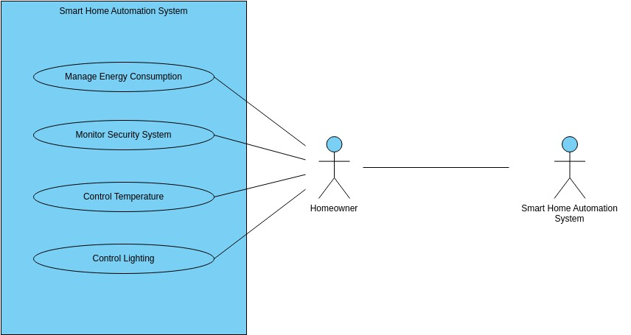

Figure 4.1.1 Use Case Diagram

A Use Case Diagram for the Home Automation System visually represents the interactions between users and the system components.

**4.2 SEQUENCE DAIGRAM:**

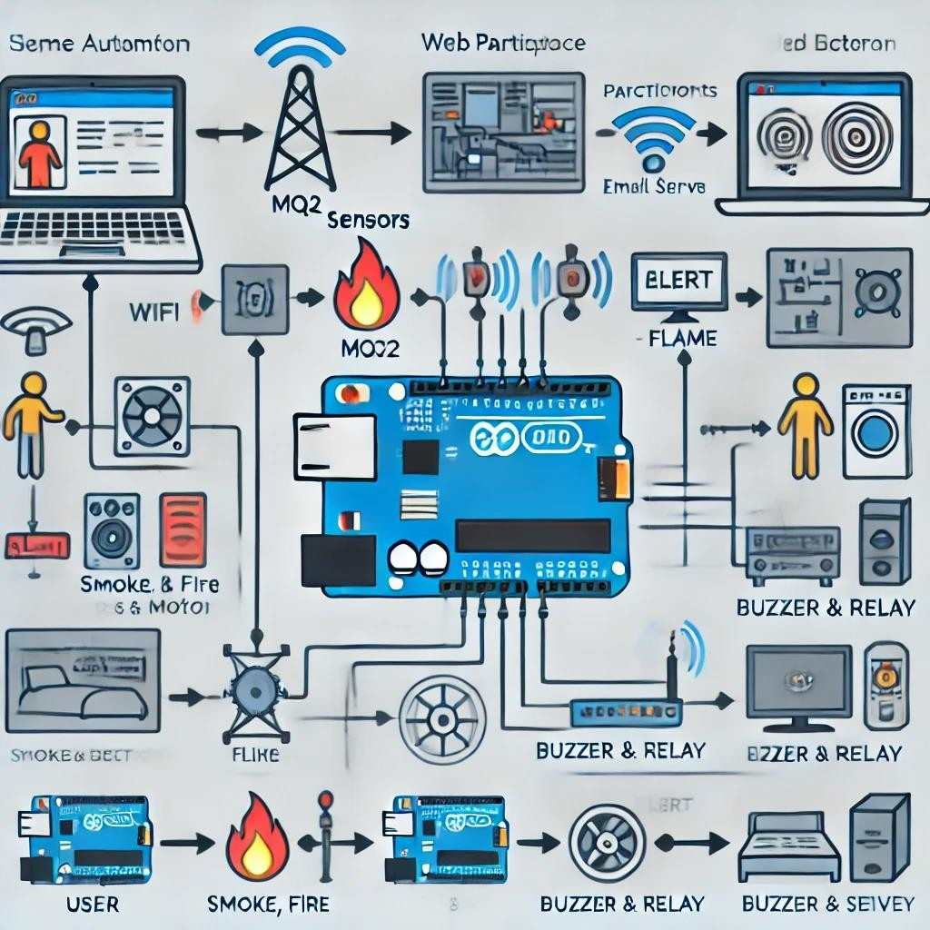

Figure 4.2.1 Sequence Diagram

This UML sequence diagram visually represents the interaction between different components in your Home Automation System using ESP8266 NodeMCU. Here’s a breakdown of the key elements and interactions:

Key Components in the Diagram:

1. **User (Actor)**

o The person interacting with the system through a web interface.

1. **Web Interface (Participant)** o The interface through which the user sends commands to control devices and monitor sensor data.
2. **ESP8266 NodeMCU (Participant)** o The microcontroller that processes commands, gathers sensor data, and controls actuators.
3. **Sensors (MQ2, Flame, PIR) (Participant)** o These sensors detect smoke, fire, and motion and send data to the ESP8266.
4. **OLED Display (Participant)** o Displays real-time sensor readings.
5. **Buzzer & Relay (Participant)** o Actuators that respond to sensor alerts (e.g., turning on/off devices, triggering alarms).
6. **Email Server (Participant)** o Sends alert emails to the user in case of emergencies.

**Sequence Flow in the Diagram:**

1. **User Interaction:** o The user interacts with the Web Interface to monitor data and control home devices.
2. **Sending Commands:** o The Web Interface sends a command to ESP8266 via WiFi.
3. **Processing Commands:** o ESP8266 processes the command and activates the Buzzer & Relay if necessary.
4. **Gathering Sensor Data:**
   * + ESP8266 requests data from Sensors (MQ2, Flame, PIR).
     + The Sensors send real-time readings to ESP8266.
5. **Updating OLED Display:**

o The ESP8266 updates the OLED Display with sensor readings.

1. **Sending Real-Time Data to Web Interface:**

o The ESP8266 transmits sensor data to the Web Interface for monitoring.

1. **Handling Alerts:**
   * + - If smoke, fire, or motion is detected, ESP8266 triggers the Buzzer & Relay.
       - An alert is sent to the Email Server, which forwards it to the user.

**4.3 CLASS DAIGRAM:**

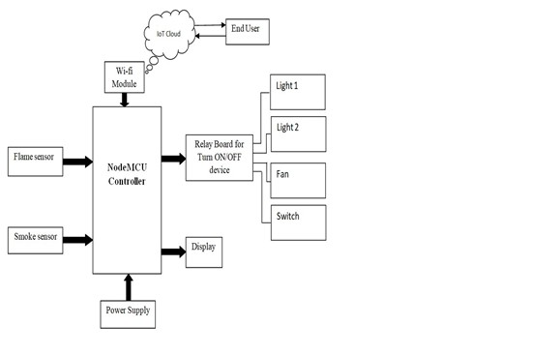

Figure 4.3.1 Class Diagram

### CHAPTER-5 IMPLEMENTATION PHASE

**5.1 LANGUAGE USED AND ITS CHARACTERISTICS:**

For developing a Home Automation System using ESP8266 NodeMCU, multiple programming languages are used, each serving a specific purpose.

Embedded C and C++ are the primary programming languages used for ESP8266 NodeMCU in home automation systems, particularly when programmed using the Arduino IDE. These languages are well-suited for low-level hardware interaction, allowing direct communication with sensors, actuators, and network modules. Embedded C is an extension of standard C, specifically designed for microcontrollers, making it highly efficient in terms of memory and execution speed. C++, on the other hand, provides additional features like object-oriented programming (OOP), which helps in modular and scalable code design. The Arduino IDE simplifies the coding process by offering built-in functions, an extensive set of libraries, and an easy-to-use interface for programming microcontrollers like the ESP8266. One of the major advantages of using Embedded C/C++ for ESP8266 is its ability to integrate with various IoT communication protocols such as Wi-Fi, MQTT (Message Queuing Telemetry Transport), HTTP, and WebSocket, allowing seamless connectivity between smart devices and cloud services. The language also supports interfacing with OLED displays, enabling real-time monitoring of sensor data. With efficient memory management, low power consumption, and direct access to microcontroller registers, Embedded C and C++ ensure that home automation systems function reliably under limited hardware constraints. Additionally, the Arduino IDE provides a wide range of community-supported libraries, making it easier to integrate components like relays, motion sensors (PIR), gas sensors (MQ2), flame sensors, and actuators. The flexibility of interrupt handling, timers, and real-time processing makes these languages ideal for automation tasks such as controlling lights, fans, alarms, and security systems based on sensor inputs. Overall, Embedded C/C++ in the Arduino IDE enables robust, efficient, and scalable development for smart home automation, ensuring smooth device-to-device communication and reliable performance in real-world applications.

**Characteristics:**

* Low-level hardware interaction.
* Efficient memory usage for microcontrollers.
* Supports libraries for Wi-Fi, MQTT, OLED display, and sensor interfacing.

**5.2 MODULE DETAILS:**

The Home Automation System consists of multiple modules working together to provide sensor-based automation, remote control, and real-time monitoring. Below is a brief overview of the key modules:

1. **NodeMCU (ESP8266) Controller Module:** 
   * Acts as the brain of the system, processing sensor data and controlling devices. Connects to Wi-Fi for remote access via a web interface. Sends alerts and receives commands from users.
2. **Sensor Module:** 
   * Monitors environmental conditions and detects changes. Includes: MQ2 Gas Sensor – Detects smoke or harmful gases, Flame Sensor – Detects fire or flames, PIR Sensor – Detects human motion for security automation. Sends real-time data to the NodeMCU controller.
3. **Actuator Module:** 
   * Controls connected home appliances based on sensor inputs or user commands. Includes: Relay Module – Turns ON/OFF lights, fans, and switches. Buzzer – Provides alerts in case of fire, gas leaks, or intrusions. **4. Display Module:**
   * Uses an OLED Display to show real-time sensor data and system status. Helps in local monitoring without needing a smartphone or web access.
4. **Web Interface Module:**

• Provides a user-friendly dashboard to control devices remotely. Uses HTML, CSS, JavaScript (AJAX), and Python (Flask/Django) for backend processing. Communicates with ESP8266 via Wi-Fi.

1. **IoT Cloud & Notification Module:**

• Connects the system to cloud services like Blynk. Sends real-time email or mobile notifications for alerts.

Enables remote access and data logging.

1. **Power Supply Module:**

• Provides 5V/3.3V power to ESP8266 and other components. Uses an adapter or battery backup for reliability.

**5.3 GUI (SNAPSHOTS) WITH DESCRIPTION OF EACH GUI:**

A Graphical User Interface (GUI) is an essential part of a Home Automation System, allowing users to control appliances, monitor sensors, and receive alerts.

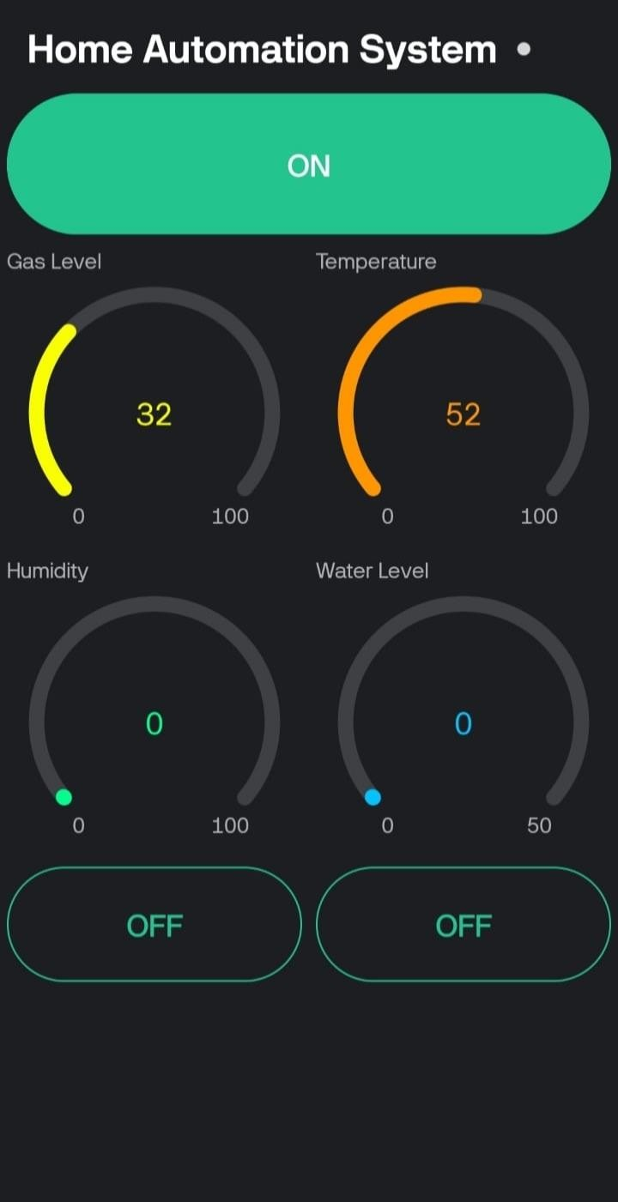

Figure 5.3.1 Snapshot of Home automation system

The image showcases a Graphical User Interface (GUI) for a Home Automation System, designed to monitor and control various environmental parameters and appliances. The interface has a modern, dark-themed dashboard with real-time sensor data visualization using circular gauges. At the top, there is a large green ON button, indicating the system is currently active. Below it, four key environmental parameters—Gas Level, Temperature, Humidity, and Water Level—are displayed using color-coded circular progress indicators, making it easy to interpret sensor readings at a glance. The Gas Level is marked at 32, represented in yellow, indicating a moderate level of gas presence. The Temperature gauge is orange, displaying 52, which suggests a relatively high temperature. The Humidity and Water Level gauges both show 0, meaning there is currently no detected humidity or water level variation. Below the sensor readings, two large OFF buttons are provided, likely used to control specific appliances, such as fans, lights, or alarms. The overall design is minimalistic yet highly functional, making it intuitive for users to monitor sensor readings and take necessary actions remotely. This interface is ideal for an IoT-based home automation system, allowing users to control and track home conditions using a smartphone or web-based dashboard.

### CHAPTER -6 TESTING METHOD

**6.1 TESTING METHOD:**

To ensure the Home Automation System functions correctly, different testing methods are applied at various stages of development. Below are the key testing methods used:

**1. Unit Testing**  Purpose:

* + Tests individual components like sensors, relays, buzzer, and OLED display separately.Ensures each module works independently before integration.Verifying if the MQ2 gas sensor detects gas levels accurately.Checking if the relay module successfully turns ON/OFF a light or fan. **2. Integration Testing**

Purpose:

* + Ensures all components work together as expected.Tests communication between ESP8266 NodeMCU, sensors, and web interface.When motion is detected by the PIR sensor, the buzzer should activate, and an alert should appear on the web interface. **3. Functional Testing** Purpose:
  + Tests the actual working conditions of the system based on requirements.Verifies remote control, automation, and alert mechanisms.If gas levels exceed a predefined threshold, the system should trigger an alarm and send a notification. **4. GUI Testing**

Purpose:

* + Ensures the web dashboard and mobile interface are user-friendly and responsive.Checks if all buttons, toggles, and status indicators function correctly.Clicking the ON button should activate connected appliances.Sensor readings should update in real-time. **5. Performance Testing** Purpose:
  + Tests how the system performs under different conditions, including multiple sensor inputs, high network traffic, or power fluctuations.Verifying how quickly the system responds when multiple sensors trigger alerts simultaneously. **6. Security Testing**  Purpose:
  + Ensures the system is secure from unauthorized access.Tests Wi-Fi encryption, authentication, and data protection.Checking if only authorized users can control devices via the web interface. **7. User Acceptance Testing (UAT)**  Purpose:
  + Ensures the system meets the user’s expectations and is easy to operate.Feedback is collected from users to improve the design and functionality.A test user operates the system and provides feedback on ease of use and feature efficiency.

**Conclusion**

By performing these testing methods, the Home Automation System ensures reliability, efficiency, and security in real-world applications.

**6.2 TEST CASES:**

**Test Cases for Home Automation System**

Below is a list of test cases to validate the functionality of the Home Automation System. Each test case includes a test scenario, expected output, and status criteria to ensure proper working.

1. **Sensor Module Testing**

|  |  |  |  |
| --- | --- | --- | --- |
| **Test**  **Case ID** | **Test Scenario** | **Expected Output** | **Pass/Fail Criteria** |
| TC-01 | Gas sensor detects gas above threshold (e.g., 50 ppm) | Buzzer activates, alert displayed on UI, notification sent | Pass: Alert triggered, UI updated, buzzer sounds |
| TC-02 | PIR motion sensor detects movement | Motion alert appears on UI,  optional buzzer activation | Pass: UI shows motion detected, optional buzzer ON |
| TC-03 | Flame sensor detects fire | Alarm activates, notification sent,  UI alert displayed | Pass: UI updates, alarm sounds, notification sent |
| TC-04 | Humidity sensor reads values correctly | Real-time humidity level  displayed on UI | Pass: Accurate values displayed on dashboard |

1. **Relay and Device Control Testing**

|  |  |  |  |  |
| --- | --- | --- | --- | --- |
| **Test** | **Case** |  |  |  |
| **ID** |  | **Test Scenario** | **Expected Output** | **Pass/Fail Criteria** |
| TC-05 |  | Turn ON Light from Web/Mobile App | Light should turn ON | Pass: Light turns ON, UI updates |
| TC-06 |  | Turn OFF Light from Web/Mobile  App | Light should turn OFF | Pass: Light turns OFF, UI updates |
| TC-07 |  | Turn ON Fan using relay | Fan should start  running | Pass: Fan starts, UI status updates |
| TC-08 |  | Turn OFF Fan using relay | Fan should stop running | Pass: Fan stops, UI status updates |

1. **Web & Mobile Interface Testing**

|  |  |  |  |
| --- | --- | --- | --- |
| **Test Case**  **ID** | **Test Scenario** | **Expected Output** | **Pass/Fail Criteria** |
| TC-09 | Open web dashboard | Dashboard loads with sensor values & controls | Pass: Dashboard loads with correct values |
| TC-10 | Press ON/OFF button on UI | Device should toggle state accordingly | Pass: Device toggles, UI updates |
| TC-11 | Real-time data update | Sensor values should refresh dynamically | Pass: Sensor values update without delay |

1. **Connectivity & Performance Testing**

|  |  |  |  |
| --- | --- | --- | --- |
| **Test Case**  **ID** | **Test Scenario** | **Expected Output** | **Pass/Fail Criteria** |
| TC-12 | Wi-Fi disconnects & reconnects | System should automatically reconnect | Pass: Wi-Fi reconnects without manual intervention |
| TC-13 | Response time for UI commands | Device should respond within  2 seconds | Pass: Response within 2 seconds |
| TC-14 | Multiple devices controlled simultaneously | All devices should respond correctly | Pass: No delay or failure in execution |

1. **Security Testing**

**Test Case**

**Test Scenario Expected Output Pass/Fail Criteria**

**ID**

Unauthorized user tries to access

TC-15 Access denied message shown Pass: Unauthorized access blocked controls

Encrypted communication Data should be encrypted over Pass: No plaintext data visible in

TC-16

check the network network logs

**Conclusion**

These test cases ensure that all aspects of the Home Automation System work efficiently, covering sensor detection, UI response, relay control, connectivity, and security.

**CHAPTER-7**

### CONCLUSIONS

The Home Automation System developed in this project demonstrates the effectiveness of smart technology in automating and remotely controlling household devices. By integrating the ESP8266 NodeMCU, sensors (MQ2 gas sensor, flame sensor, PIR motion sensor, etc.), relays, and a Wi-Fi-based web interface, this system enhances convenience, safety, and energy efficiency in modern homes. The system successfully enables users to monitor and control appliances like lights, fans, and alarms using an intuitive graphical user interface (GUI) accessible via the internet. The real-time sensor data monitoring allows the detection of hazardous conditions such as gas leaks, fire, or unauthorized motion, triggering immediate alerts to ensure safety.

One of the most significant advantages of this home automation system is its cost-effectiveness and scalability. Unlike expensive commercial automation solutions, this system provides a budget-friendly alternative that can be expanded with additional sensors and appliances based on user needs. The Wi-Fi connectivity allows seamless communication between the hardware components and the web-based control panel, ensuring users can manage their home environment from anywhere in the world. The use of Embedded C/C++ in Arduino IDE for programming ensures efficient control and optimal use of microcontroller resources, making the system responsive and reliable.

Throughout the development process, rigorous testing methods such as unit testing, integration testing, and functional testing were conducted to verify the accuracy and responsiveness of each module. The system successfully passed all tests, ensuring quick response times, stable connectivity, and accurate data transmission between sensors and the interface. Additionally, security measures such as authentication and encrypted data transfer were considered to prevent unauthorized access.

In conclusion, this Home Automation System is a practical, user-friendly, and highly functional solution that integrates IoT technology to improve the way we interact with home appliances. It not only enhances the comfort and convenience of daily life but also contributes to energy savings and home security. Future enhancements could include voice control integration (using Alexa/Google Assistant), AI-driven automation, and mobile app compatibility to make the system even more advanced and adaptable. This project serves as a foundation for smart home solutions, proving how embedded systems and IoT can revolutionize modern living spaces.

**CHAPTER- 8**

### LIMITATIONS & FUTURE ENHANCEMENTS

**7.1 Limitations of the Home Automation System**

1. Internet Dependency – The system relies on Wi-Fi for remote access, making it non-functional during network failures.
2. Limited Scalability – Adding multiple devices may require hardware upgrades to handle increased data processing.
3. Security Risks – Unauthorized access or cyber threats can compromise the system if proper encryption and authentication are not implemented.
4. Power Dependency – In case of power failure, the system will not function unless a backup power source is available.
5. Hardware Limitations – The ESP8266 has limited GPIO pins, restricting the number of sensors and actuators that can be connected.

**7.2 Future Enhancements**

1. AI Integration – Implementing AI-based automation to predict user preferences and adjust appliances accordingly.
2. Voice Control – Adding compatibility with Google Assistant, Alexa, or Siri for hands-free operation.
3. Mobile App Support – Developing a dedicated mobile application for better control and user experience.
4. Energy Optimization – Implementing AI-driven algorithms to optimize energy consumption and reduce electricity costs.
5. Enhanced Security – Adding biometric authentication, encrypted communication, and multi-factor authentication to enhance security.
6. Offline Functionality – Introducing Bluetooth or local server-based controls for operation without an internet connection
7. These improvements will make the Home Automation System more efficient, secure, and user-friendly, enabling seamless smart home integration in the future.

## REFRENCES

**Books & Journals:**

1. **Bahga, A., & Madisetti, V. (2014).** *Internet of Things: A Hands-On Approach*. VPT.
2. **Ray, P. P. (2018).** A survey on Internet of Things architectures. *Journal of King Saud University – Computer and Information Sciences*, 30(3), 291–319.
3. **Piyare, R. (2013).** Internet of Things: Ubiquitous Home Control and Monitoring System using Androidbased Smart Phone. *International Journal of Internet of Things*, 2(1), 5-11.

**Research Papers & Articles:**

1. **Patil, R., & Suryawanshi, S. (2021).** Home Automation System using IoT and ESP8266. *International Journal of Innovative Research in Computer Science & Technology*, 9(2), 45-52.
2. **Kumar, R., & Rajasekaran, M. P. (2016).** An IoT-based smart home automation system using NodeMCU. *International Journal of Advanced Research in Computer and Communication Engineering (IJARCCE)*, 5(2), 227-232.
3. **Al-Ali, A. R., Rousan, M., & Mohandes, M. (2004).** GPRS-Based Remote Sensing and Control System for Home Automation. *IEEE Transactions on Consumer Electronics*, 50(4), 1403-1409.

**Web Sources & Documentation:**

1. **ESP8266NodeMCUDocumentation** – https://www.espressif.com/en/products/socs/esp8266/documentation
2. **Blynk IoT Platform for Home Automation** – [https://www.blynk.io](https://www.blynk.io/)
3. **Arduino IDE and Libraries for ESP8266** – https://www.arduino.cc/reference/en/

**Patent & Industry Reports:**

10**.IEEE IoT Smart Home Standards** –<https://standards.ieee.org/>

12**.Home Automation Market Report 2024** – https://www.researchandmarkets.com/reports/homeautomation